All results presented in this file are simulated in the same conditions as that of the previous file.

We obtained the following **temperature profile** after 0.1 seconds

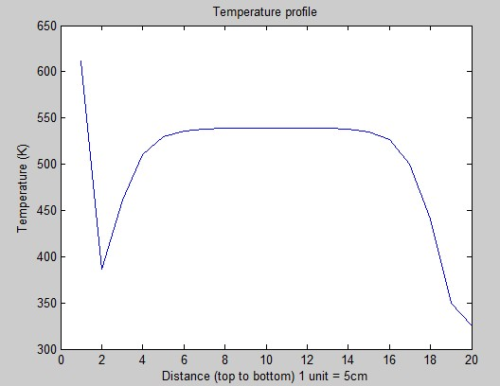

Temperature vs time at the surface

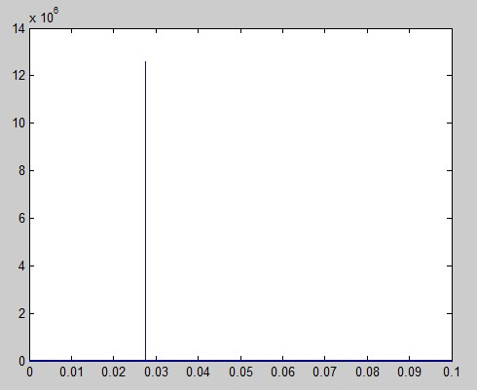

The following are the plots of concentration versus time

**Cellulose:**

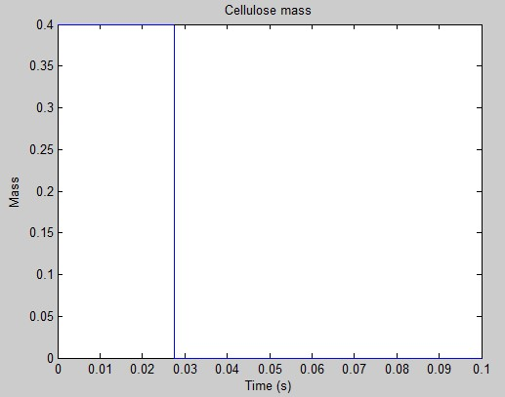

**Hemi-Cellulose:**

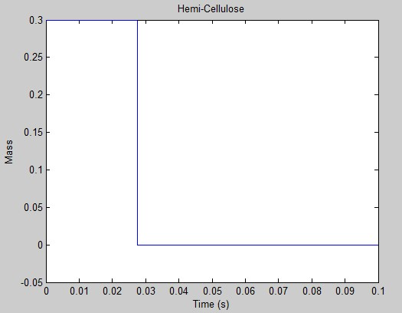

**Carbon Dioxide:**

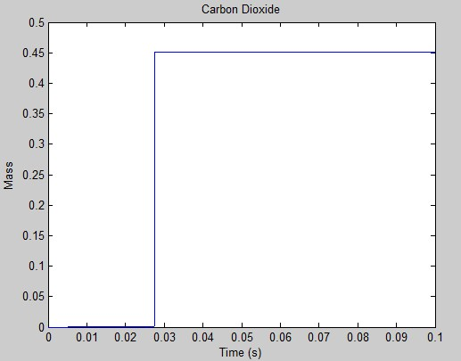

Similar concentration versus time graphs are obtained for all other species as well. The reaction is getting completed when the temperature spikes.

Additionally, MATLAB is giving the following warning:

“*Matrix is close to singular or badly scaled. Results may be inaccurate.”*